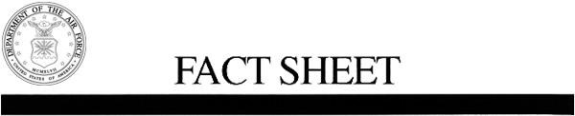
U.S. Air Force Fact Sheet
15TH OPERATIONS GROUP
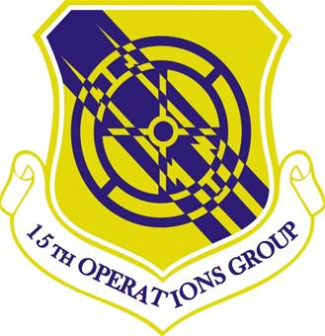
15th Operations Group Shield

15TH OPERATIONS GROUP
Lineage and Honors History of the 15th Operations Group (PACAF)
Lineage. Established as 15 Operations Group on 1 Apr 1992. Activated on 13 Apr 1992.
Assignments. 15 Air Base (later, 15 Airlift) Wing, 13 Apr 1992-.
Components. Squadrons: 65 Airlift, 13 Apr 1992; 535 AS, 18 Apr 05; 15 OSS, 20 Dec 05; 25 ASOS, 1 Aug 94-1 Nov 08. 15 Air Base (later, 15 Airlift) Wing, 13 Apr 1992-18 May 2010; 15 Wing, 18 May 2010-. 96 Air Refueling, 23 Jul 2010; 19 Fighter, 4 Oct 2010
Stations. Hickam AFB, HI, 13 Apr 1992-18 May 2010; Joint Base Pearl Harbor-Hickam, 18 May 2010-.
Commanders. Col Jerry C. Angley, 26 Apr 1992; Col James E. Stieber, 21 Jul 1992; Col Kenneth L. Black, 27 Apr 1994; Col Frank R. Sizemore, 11 Jul 1996; Col Robert J. Settle II, 14 Jul 1998; Col David A. Razo, 18 Apr 2000; Lt Col Michael A. Fleck 4 Jan 2002; Col Raymond G. Torres 3 Jul 02; Col Jeffrey L. Fraser 28 Apr 03; Col Steven L. Groenheim; 6 May 05; Col Andrew M. Hockman 16 Mar 07-. Col Andrew M. Hockman 16 Mar 2007; Col Jeffrey W. Morgan, 30 Jun 2009; Col David D. Baldessari, 8 Jul 2011; Col Michael Merritt, 21 June 2013; Col Charles Velino, 18 June 2015.
Aircraft. C-135, 1992-2003; C-37, 2002-, C-40, 2003-; C-17, 2005-; KC-135, 2010-; F-22, 2010-.
Operations. Established in Apr 1992 as part of the objective wing reorganization, the 15th Operations Group assumed responsibility from the 15th Air Base Wing for managing operational matters at Hickam AFB, Bellows AFS, and Wake Island Airfield. From 1992, the group had one airlift squadron assigned and equipped with C-135 (after 2003 C-37 and C-40) aircraft, which provided transportation for the Commander, US Pacific Command, Commander, Pacific Air Forces, and other high ranking civilian, military, and foreign dignitaries. From 2006, the group had an additional airlift squadron equipped with C-17A aircraft. From 2010, the group had a refueling squadron equipped with KC-135 aircraft, operated in conjunction with the 154th Wing of the Hawaii National Guard, and a fighter squadron equipped with F-22 Raptor aircraft, also operated in conjunction with the 154th Wing. Also provided command and control for the defense of the Hawaiian Islands.
Service Streamers. None
Campaign Streamers. None
Armed Forces Expeditionary Streamers. None
Decorations. Air Force Outstanding Unit Awards: 13 Apr 1992-30 Jun 1993; 1 Oct 1993-30 Sep 1995; 1 Oct 1995-1 Aug 1997; 2 Aug 1997-1 Aug 1999; 29 Nov 1999-30 Nov 2001; 1 Nov 2002-31 Oct 2004.
Lineage, Assignments, Components, Stations, and Honors through 28 Oct 2003. Commanders, Aircraft, and Operations through 31 Dec 2000.
Emblem. Group will use the wing emblem with group designation in the scroll.
This fact sheet is current as of September 2015.

