15TH MAINTENANCE SQUADRON
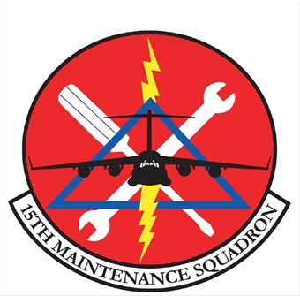
15th Maintenance Squadron

Lineage and Honors History of the 15 Maintenance Squadron (PACAF)
Lineage. Constituted 15 Consolidated Aircraft Maintenance Squadron on 17 Jun 1957. Activated on 8 Jul 1957. Discontinued on 1 Jul 1960. Inactivated, and consolidated (22 Oct 1984), with the 15 Field Maintenance Squadron, which was constituted, and activated, on 17 Apr 1962. Organized on 1 Jul 1962. Inactivated on 1 Jul 1971. Activated on 1 Nov 1971. Redesignated 15 Consolidated Aircraft Maintenance Squadron on 1 Jul 1986. Redesignated 15 Maintenance Squadron 13 Apr 1992. Inactivated on 1 Apr 1999. Activated on 7 Jul 2005.
Assignments. 15 Fighter Group (Air Defense), 8 Jul 1957-1 Jul 1960. Tactical Air Command, 17 Apr 1962; 15 Tactical Fighter Wing, 1 Jul 1962; 1 Tactical Fighter Wing, 1 Oct 1970-1 Jul 1971. 15 Air Base Wing, 1 Nov 1971; 15 Logistics Group, 13 Apr 1992-1 Apr 1999. 15 Maintenance Group, 7 July 2005-.
Stations. Niagara Falls Municipal Airport, NY, 8 Jul 1957-1 Jul 1960. MacDill AFB, FL, 1 Jul 1962-1 Jul 1971. Hickam AFB, HI, 1 Nov 1971-1 Apr 1999. Hickam AFB, HI, 7 Jul 2005-.
Service Streamers. None.
Campaign Streamers. None.
Armed Forces Expeditionary Streamers. None.
Decorations. Air Force Outstanding Unit Awards: 1 Jan 1965-1 Jun 1966; 1 Jan-31 Dec 1969; 1 Jan 1970-1 Jun 1971; 4 Apr-3 Sep 1975; 25 Feb-25 Mar 1986; 1 Jul 1989-30 Jun 1991; 13 Apr 1992-30 Jun 1993; 1 Oct 1993-30 Sep 1995; 1 Oct 1995-1 Aug 1997.
Lineage, Assignments, Stations, and Honors through 13 Jul 2005.

