15TH MAINTENANCE GROUP
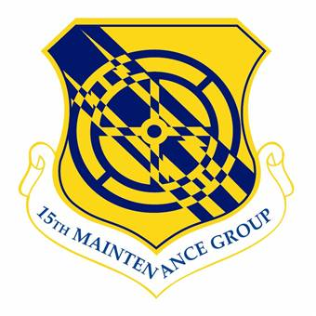
The shield of the 15th Maintenance Group

Lineage: Established as 15 Air Depot Group on 5 Jan 1942. Activated on 28 Jan 1942. Inactivated on 15 Mar 1946. Disestablished on 27 Sep 1984. Reestablished, and redesignated 15 Logistics Group, on 1 Apr 1992. Activated on 13 Apr 1992. Redesignated 15 Maintenance Group on 30 Sep 2002. Inactivated on 11 Jul 2003. Activated on 22 Jun 2005.
Assignments: San Antonio Air Depot, 28 Jan 1942; V Air Service Area Command, 18 Jun 1943; 5295 Air Service Area Command (P), 1 Sep 1945; Far East Air Service Command, 1 Jan-15 Mar 1946. 15 Air Base (later, 15 Airlift) Wing, 13 Apr 1992-11 Jul 2003. 15 Airlift Wing, 22 Jun 2005-. 15 Airlift Wing, 22 Jun 2005-18 May 2010; [Add] 15 Wing, 18 May 2010-present.
Stations: Duncan Fld, TX, 28 Jan 1942; Kelly Fld, TX, 11 Mar-6 May 1943; Camp Mt. Louisa (Townsville), Australia, 18 Jun 1943-2 Nov 1944; Tacloban (Leyte), Phillipine slands, 19 Nov 1944-15 Mar 1946. Hickam AFB, HI, 13 Apr 1992-11 Jul 2003. Hickam AFB, HI, 22 Jun 2005-. Hickam AFB, HI 22 Jun 2005-18 May 2010; [Add] Joint Base Pearl Harbor Hickam, 18 May 2010-present.
Commander List: 15 Logistics Group: Col Wallace E. George Jr., 1 Oct 1986; Col Richard McMorris, 16 May 1990; Col Jack D. Deligans, 18 Jul 1991; Col James D. Herrick, 5 Aug 1994; Col Terry W. Jensen, 1 Oct 1996; Col Charles L. Renfro, 8 Sep 1998; Col Stephen Ribuffo, 2 Jul 2000; Col David G. Smith, 10 Jul 2002; 15 Maintenance Group: Col David G Smith, 10 Jul 2002-11 Jul 2003; 15 Maintenance Group: Col Larry F. Stephens, 22 Jun 2005; Col John Lipinski, 27 Jun 2006; Col Richard S. Marks, 24 Jul 2008; Col Michael J. Novotny, 17 Aug 2010; Col David Pastore 9 July 13; Col Robert Copes, 28 Jul 2015.
Service Streamers: World War II American Theater.
Campaign Streamers: World War II: Leyte 1944-1945.
Armed Forces Expeditionary Streamers: None.
Decorations: Air Force Outstanding Unit Awards: 13 Apr 1992-30 Jun 1993; 1 Oct 1993-30 Sep 1995; 1 Oct 1995-1 Aug 1997; 2 Aug 1997-1 Aug 1999; 29 Nov 1999-30 Nov 2001. Philippine Presidential Unit Citation (WWII).
Emblem. Group will use the wing emblem with the group designation in the scroll.

