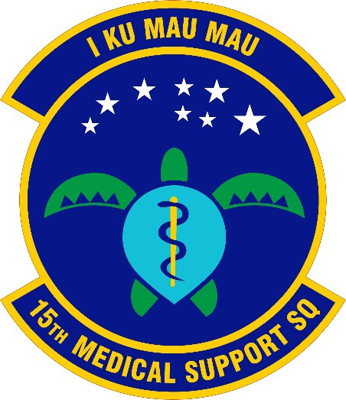

Lineage and Honors History Of the
15th MEDICAL SUPPORT SQUADRON (PACAF)

Lineage. Constituted 15th Medical Support Squadron on 25 Aug 1994. Activated on 15 Sep 1994 (SO GA-39, 1 Sep 1994).

Honors:
Service Streamers: None

Campaign Streamers: None

Armed Forces Expeditionary Streamers: None

Decorations: Air Force Outstanding Unit Award: 22 Sep 1994-30 Sep 1995; 1 Oct 1995 – 1 Aug 1997; 2 Aug 1997 – 1 Aug 1999; 1 Nov 2002 – 31 Oct 2004;
1 Nov 2004 – 31 Oct 2006; 1 Nov 2006 – 31 Oct 2007.

Assignments: 15th Medical Group, 15 Sep 1994 – PRESENT. Stations: Hickam AFB, HI, 15 Sep 1994 – PRESENT. Commanders:
Lt Col Charles C. Armstead, 15 Sep 1994 – 15 Jun 1997; Lt Col Karen E. Jones, 16 Jun 1997 – 16 Nov 1999; Col William W. Wilson, Jr., 17 Nov 1999 – 8 Feb 2000; Lt
Col John L. Binder, 9 Feb 2000 – 14 Jan 2002; Lt Col Gregory Stewart, 15 Jan 2002 –
20 Jul 2004; Lt Col Edwin A. Hurston, 21 Jul 2004 – 15 Jun 2006; Lt Col Charles
Nelsen, 16 Jun 2006 – 15 Jun 2008; Lt Col Curt B. Pritchard, 16 Jun 2008 – 14 Jun 2010; Lt Col Christopher A. Dun, 15 Jun 2010 – 11 Jun 2012; Lt Col Mark R. Lamey, 12 Jun 2012 – 17 Jun 2014; Lt Col Sarah E. Cuciti, 18 Jun 2014 – 21 Jul 2016; Lt Col
Miguel A. Guevara, 22 Jul 2016 – 21 Nov 2017; Lt Col Jennifer R. Bein, 22 Nov 2017
– 27 Jun 2018; Lt Col James A. Stewart, 28 Jun 2018 – PRESENT.

Emblem: Approved 22 Sep 2020.

Date Prepared. 4 Aug 1999 Prepared by Helen Weaver Approved by Judy G. Endicott
Updated by James L. Burrett, 29 Sep 2020

