# Air Force Historical Research Agency - Fact Sheet (Printable) : 15 MEDICAL GROUP (... Page 1 of 1

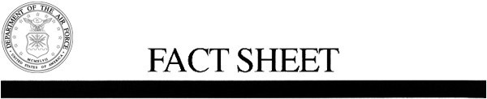

## U.S. Air Force Fact Sheet

15 MEDICAL GROUP (PACAF)

**Lineage**. Constituted as USAF Dispensary, Hickam on 12 May 1971. Activated on 17 May 1971. Redesignated as: USAF Clinic, Hickam on 1 Sep 1972; 15 Medical Group on 15 Sep

1987.

**Assignments**. 6486 Air Base Wing, 17 May 1971; 15 Air Base (later, 15 Airlift; 15) Wing, 1 Nov

1971-.

**Stations**. Hickam AFB (later, Joint Base Pearl Harbor-Hickam), HI, 17 May 1971-.

**Service Streamers**. None.

**Campaign Streamers**. None.

## Armed Forces Expeditionary Streamers. None.

**Decorations**. Air Force Outstanding Unit Awards: 4 Apr-3 Sep 1975; 25 Feb-25 Mar 1986; 1

Jul 1989-30 Jun 1991; 1 Jul 1991-30 Jun 1993; 1 Oct 1993-30 Sep 1995; 1 Oct 1995-1 Aug

1997; 2 Aug 1997-1 Aug 1999; 1 Nov 2002-31 Oct 2004; 1 Nov 2004-31 Oct 2006; 1 Nov

2006-31 Oct 2007.

## Lineage, Assignments, Stations, and Honors through Feb 2014.

**Supersedes** statement prepared on 22 Mar 2002.

**Emblem**. Group will use the wing emblem with the group designation in the scroll.

**Prepared by** Patsy Robertson.

**Reviewed by** Carl E. Bailey.

# [http://www.afhra.af.mil/factsheets/factsheet_print.asp?fsID=21471&page=1](http://www.afhra.af.mil/factsheets/factsheet_print.asp?fsID=21471&amp;page=1) 5/7/2014